Hossein Elgafy, MD, FRCSEd, FRCSC, MBA Professor of Orthopedics Chief of Spine

Ankylosing spondylitis (AS) is an inflammatory arthritis that primarily affects the spine. AS affects men more often than women. It causes inflammation of the spinal joints (vertebrae) that can lead to chronic pain. Over time it can cause the vertebrae to fuse. This fusion makes the spine less flexible and can result in a hunched-forward posture. If ribs are affected, it can be difficult to breathe deeply. Sometimes the eyes become inflamed as well, a condition known as iritis or uveitis.
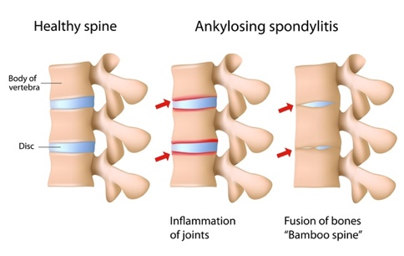

X-ray showing bamboo spine, a radiographic feature
of AS that occurs as a result of vertebral body fusion

AS can also cause inflammation, pain, and stiffness in other areas of the body, the most commonly affected areas are:

The sacroiliac (SI) joints between the base of the spine and the pelvis, this is one of AS’s hallmark features

The places where the tendons and ligaments attach to bones, mainly in the spine, but sometimes along the back of the heel

The cartilage between the breastbone and ribs

The hip and shoulder joints
Causes: AS has no known specific cause, though genetic factors seem to be involved. Most individuals who have ankylosing spondylitis also have a gene that produces a genetic marker, a protein called HLA-B27.
Researchers suspect that other genes along with a triggering environmental factor such as a bacterial infection are needed to activate AS in susceptible people. One hypothesis is that AS may start when the defenses of the intestines break down and certain bacteria pass into the bloodstream, triggering changes in the immune response.

Risk Factors: The risk factors that predispose a person to AS include:

Testing positive for the HLA-B27 marker

A family history of AS

Frequent gastrointestinal infections
- Gender as men are more likely to develop AS
- Age, onset generally occurs in late adolescence or early adulthood

Diagnosis: A thorough physical exam, a review of medical history and family history of AS, as well as x-rays and blood work (including a test for HLA-B27) are factors in making a diagnosis.

Disease Prognosis: AS is a chronic, lifelong disease characterized by painful episodes which are followed by temporary periods of remission when symptoms subside.
The severity of AS varies greatly from person to person, and not everyone will experience the most serious complications or have spinal fusion. Some may experience only intermittent back pain and discomfort, while others may experience severe pain and stiffness over multiple areas of the body.
Complications:
- Progressive Spine Kyphosis (forward bending of the spine): AS is associated with osteopenia and spine fractures can occur with minor trauma or even without any trauma.
  - These fractures usually do not heal resulting into progressive kyphosis
  - Progressive kyphosis makes it difficult for the patient to lie down or gaze forward, which can interfere with daily activities and adversely impact the quality of life
  - Surgical treatment is the only way to simultaneously relieve back pain and correct kyphosis in AS patients with pathological fractures

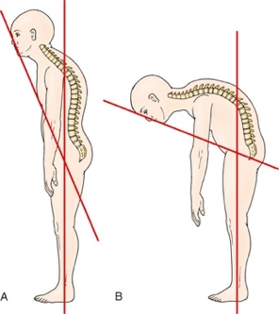
A-Normal alignment of the spine, B- kyphosis with loss of forward gaze
- Acute Unstable Spine Fractures: This can present initially with increasing pain after a mild fall, or the patient will notice the spine is more flexible than usual. The patient should seek immediate medical attention such as visiting the Emergency Room as these fractures are often very unstable, cause spinal cord injury and may result into paralysis
CT of the neck showing unstable fracture that reqiured surgery
- Eye inflammation (uveitis): One of the most common complications of AS is uveitis, that can cause rapid-onset eye pain, sensitivity to light and blurred vision
- Heart problems: AS can cause problems with the aorta. The inflamed aorta can enlarge to the point that it distorts the shape of the aortic valve in the heart, which impairs its function

Non-Surgical Treatment: Currently, there is no cure for AS, but treatments can reduce the pain and possibly slow progression of the disease.
Anti-inflammatory medication NSAIDs such as Naproxen can help with inflammation. Additionally, these drugs may also help with the pain and stiffness that comes naturally with inflammation.
Biologic medication targets cell proteins in the body that lead to inflammation and helps with stiffness and pain.

Surgical Treatments for Spine Kyphosis in AS: Surgery may be considered depending on many variables such as symptoms, severity of the spinal abnormalities, age, and lifestyle. If the patient has kyphosis affecting their ability to look forward a surgical management may be considered. A spine osteotomy may be considered in which the surgeon cuts and extracts a wedge of the bone ends, then stabilizes the spine with screws and rods to correct the spine alignment. These can be done in the neck or the lower back.

