Hossein Elgafy, MD, FRCSEd, FRCSC, MBA Professor of Orthopedics Chief of Spine

What is spinal stenosis?
Stenosis is a medical term used to describe a condition where a normal-size opening has become narrow. Spinal stenosis is a narrowing of the spaces within the spine, which can put pressure on the nerves that travel through the spine.
Consider a water pipe. Over time, rust and debris builds up on the walls of the pipe, thereby narrowing the passageway that normally allows water to flow freely. The spinal canal is a hollow vertical hole that contains the spinal cord. The neuroforamen are the passageways that are naturally created between the vertebrae through which spinal nerve roots exit the spinal canal.
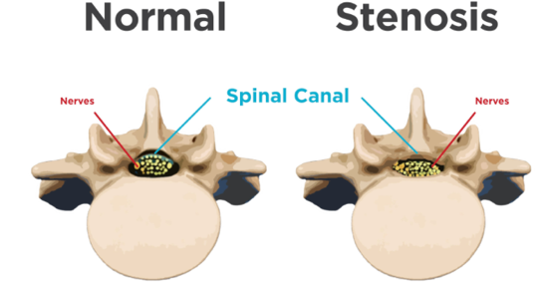
The area affected most commonly is the lower back followed by the neck and it can affect one level or multiple levels of the spine.
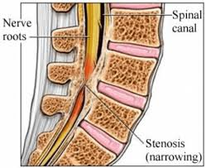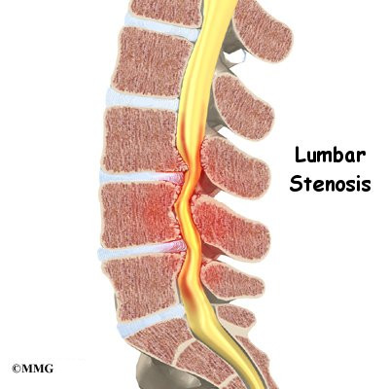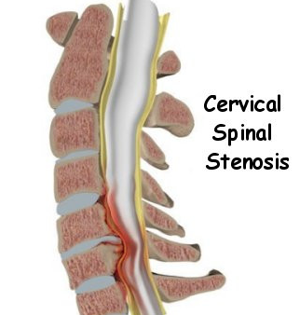
Lumbar (low back) and cervical (neck) spinal stenosis is illustrated above. Notice the narrowed areas in the spinal canal (reddish-colored areas). As the canal space narrows, the spinal cord and nearby nerve roots are squeezed causing different types of symptoms. This may occur at one level or multiple levels of the spine.

Causes: Some individuals are born with a small spinal canal. But most spinal stenosis occurs when something happens to narrow the open space within the spine.
Wear and tear of the spine: Spinal stenosis is most commonly caused by wear-and-tear on the spine related to degenerative changes in the disc and joints and the spine ligaments that become stiff and thickened over time.
Herniated discs: When the padding between the vertebrae dries out with age, cracks can appear. These small cracks allow the soft padding to leak and cause the discs to press on the spinal cord.
Tumors: Occasionally, abnormal growths form inside the spinal cord, or from the boney structure surrounding the spinal cord.
Injuries: Spinal injuries can cause a displaced bone from a spinal fracture to damage the contents of the spinal canal.
Investigations: Spinal imaging such as MRI and CT myelogram, CT done after injection of a dye into the spinal canal, can differentiate these causes.

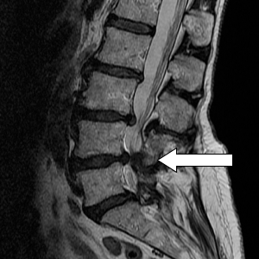

MRI of the lower back and the neck showing spinal stenosis

Symptoms: Some people with spinal stenosis may not have symptoms. When symptoms occur, they often start gradually and worsen over time. Symptoms vary depending on the location of the stenosis and which nerves are affected.

In the lower back:
- Numbness or tingling in foot or leg
- Weakness in foot or leg
- Pain or cramping in one or both legs when standing for long periods of time or walking, which usually eases when bending forward or sitting
- Back pain

In the neck:
- Numbness or tingling in hand, arm, foot or leg
- Weakness in hand, arm, foot or leg
- Problems with walking and balance
- Neck pain
- In severe cases, bowel or bladder dysfunction (urinary urgency and incontinence)

Non-surgical management:
- Physical therapy and home exercise program
- Over the counter muscle relaxant and anti-inflammatory medications are analgesics used to reduce swelling and inflammation such as aspirin and ibuprofen
- Short course of oral corticosteroid medication for more severe leg pain because of their very powerful anti-inflammatory effect
- Antidepressants such as amitriptyline can be used to help ease chronic pain
- Anti-seizure drugs in some cases may be prescribed to alleviate pain
- Spine injections: Epidural injections, cortisone injections into the spinal column can reduce swelling
Surgical management: The goal of surgery is to alleviate pressure on the spinal cord and nerves. Surgery may be needed for severe pain or if there is a neurological loss. It can relieve pressure permanently. Several types of surgery are used to treat spinal stenosis:
- Laminectomy is the most common type of surgery. A surgeon removes part of the vertebrae to provide more room for the nerves
- Foraminotomy is a surgery that is done to widen the part of the spine where the nerves exit
- Spinal fusion is typically performed in more severe cases, especially when multiple levels of the spine are involved, to prevent instability. Bone grafts or metal implants are used to attach the affected bones of the spine together
Emergency surgery: Very rarely, an acute large disc herniation causing severe spinal stenosis may press on the nerves in the low back causing loss of bladder or bowel control, a condition known as cauda equina. This is usually accompanied by numbness and tingling in the groin or genital area. It is one of the few indications that you need surgery immediately for a herniated lumbar disc to relieve the pressure on the nerve to avoid permanent problems.

