Hossein Elgafy, MD, FRCSEd, FRCSC, MBA Professor of Orthopedics Chief of Spine

The disc is made of a tough outer layer and a gel-like center. With age, the center of the disc may start to lose water content, making the disc less effective as a cushion. As a disc deteriorates, the outer layer can also tear. This can allow displacement of the disc's center (called a herniated or ruptured disc) through the tear into the space occupied by the nerves and spinal cord. The herniated disc can then press on the nerves and spinal cord.
Cervical disc prolapse is illustrated above. Notice the narrowed areas in the spinal canal (reddish-colored areas). As the canal space narrows, the spinal cord and nearby nerve roots are squeezed causing different types of symptoms. This may occur at one level or multiple levels of the spine.
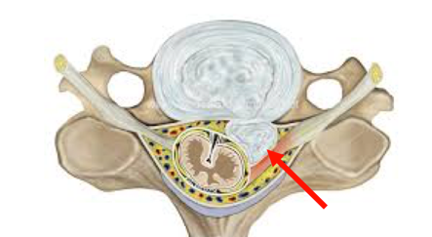
Cervical disc prolapse is illustrated above on one side of the spine compressing nearby nerve root causing pain down one arm.
Cervical disc herniation is a common cause of pain in the neck, between the shoulder blades, and down the arms, hands and fingers. Sensations of numbness and tingling are typical symptoms, and some patients report muscle spasms. Certain positions and movement can aggravate and intensify pain.
In some patients, a cervical herniated disc can cause spinal cord compression where disc material pushes on the spinal cord. Spinal cord compression symptoms include awkward or stumbling gait, difficulty with fine motor skills in the hands and arms and tingling or “shock” type feelings down the body or into the legs. This condition is called cervical myelopathy and usually requires surgical treatment to take the pressure of the spinal cord.
Non-surgical management: Many patients will improve with nonsurgical treatment. The goals of nonsurgical treatment are to reduce the irritation of the nerve from the herniated disc material, relieve pain and improve the physical condition of the patient.
- After the onset of pain from a herniated cervical disc, a short (one to two days) period of rest may be beneficial
- Physical therapy and home exercise program, physical therapist may use traction, electric stimulation, hot packs and cold packs to reduce pain, inflammation and muscle spasm
- Over the counter muscle relaxant and anti-inflammatory medications are used to reduce swelling and inflammation such as aspirin, ibuprofen (Motrin, Advil) and naproxen (Aleve)
- Short course of oral corticosteroid medication for more severe pain because of their very powerful anti-inflammatory effect
- Spine injections: Epidural injections or nerve block may be recommended for severe arm pain. These are injections of corticosteroid into the epidural space (the area around the spinal nerves). The purpose of the injection is to reduce inflammation of the nerve and the disc
Surgical management: Cervical spine surgery may be recommended if pain and symptoms progressively worsen despite nonoperative therapies. If the herniated disc is compressing the spinal cord causing weakness and problem with balance (cervical myelopathy) surgery may be necessary.
- The goal of surgery is to alleviate pressure on the spinal cord and nerves
- Depending on the location of the herniated disc, the surgery may be performed from the front or back of the neck to reach the spine
- The technical decision of whether to perform the operation from the front or the back of the neck is influenced by many factors including the exact location of the disc herniation, spine alignment and how many levels are affected
- With either approach, the disc material is removed from the nerve usually with good results
- Because removal of the herniated disc fragment from the front removes most of the disc in addition to the herniated portion, fusion is often recommended and performed at the same time

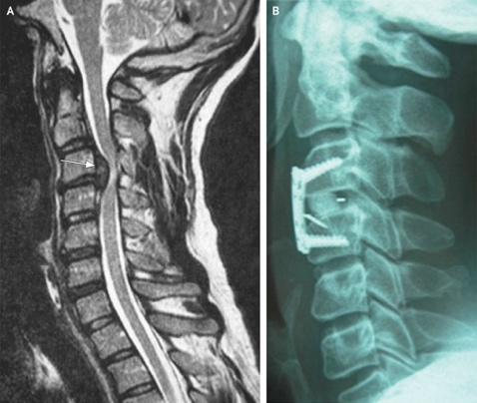
The above images are MRIs of a disc herniation in the cervical spine at C3-C4. The herniation is pressing the spinal canal and was managed surgically by going through the front of the neck taking the disc out to remove the pressure of the spinal cord and fusion by inserting a spacer in the disc space and instrumentation inserting plate and screws.
Postoperative management:
- Many patients are able to go home within 24 hours after surgery
- Soft collar for 2 weeks
- A thorough postoperative rehabilitation program is advisable to help resume the activities of daily living. Most patients will benefit from a postoperative exercise program or supervised physical therapy after surgery
- Surgery is very effective in reducing the pain in the arms and shoulders caused by a herniated cervical disc. However, some neck pain may persist
- Most patients respond well to discectomy; however, as with any surgery, there are some risks involved. The most common is developing difficulty with swallowing for a while after anterior neck surgery due to irritation of the feeding tube, esophagus, from surgery

