Hossein Elgafy, MD, FRCSEd, FRCSC, MBA Professor of Orthopedics Chief of Spine

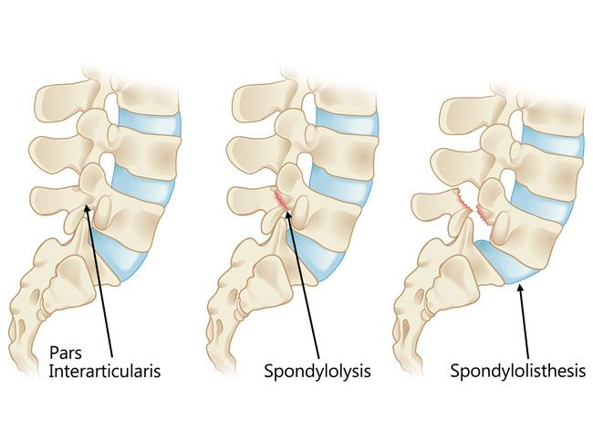
Spondylolysis is a condition in which there is a defect in a portion of the spine called the pars interarticularis (a small segment of bone joining the joints in the back of the spine). With the condition of spondylolysis, the pars interarticularis defect can be on one side of the spine only or both sides. The most common level it is found is at L5-S1, although it can occur at L4-5 and rarely at a higher level. Spondylolysis is the most common cause of isthmic spondylolisthesis, in which one vertebral body is slipped forward over another. Isthmic spondylolisthesis is the most common cause of back pain in adolescents; however, most adolescents with spondylolisthesis do not actually experience any symptoms or pain. The most common symptom is back and/or leg pain that limits a patient's activity level.
Spondylolysis only refers to the separation of the pars interarticularis (a small bony arch in the back of the spine between the facet joints), whereas spondylolisthesis refers to anterior slippage of one vertebra over another in the front of the spine.
Spondylolysis develops most commonly in adolescents. It is seen more often in athletes than in people who do not actively participate in sports. Approximately 3% to 7% of the general population is thought to have spondylolysis. It is suspected that it occurs most frequently in young athletes who are involved in sports that require repeated hyperextension of the lower back.
The majority of adolescents with spondylolysis do not have symptoms, or their symptoms are mild and are often overlooked. If the spondylolysis is not correctly identified and managed, there is a chance that the affected area may not heal leading to the slippage of the spine which is now called spondylolisthesis and low back pain may reoccur.

Activity Restrictions: In the past, patients have often been advised to limit their activities especially participation in sports and active exercise to avoid causing advancement of the spondylolysis. However, new information developed from modern imaging tests and recent research indicates that reduced activity to protect the spondylolysis from slipping may not always be necessary. Rest is only necessary if the patient becomes symptomatic. Rest can help eliminate the pain, and when the pain resolves the patient can resume normal activities.
Treatments for Active Spondylolysis: The recommended treatment program for active spondylolysis is usually a combination of the following:
Non-Surgical management:
- Bracing to immobilize the spine for a short period approximately three months to allow the pars defect to heal
- Anti-inflammatory medication for pain
- Stretching, beginning with gentle hamstring stretching and progressing with additional stretches over time
- Local anesthetic and steroid injection around the pars defect for severe back pain that failed to respond to previous measures
Surgical Management: Spondylolysis that is not healing or neurological components can require surgery to provide internal fixation and stability to the area.
Treatments for Inactive Spondylolysis: For inactive spondylolysis, bracing is usually not necessary. In many cases, however, the spondylolysis will be discovered long after the pars defect has already healed. This condition is often referred to as chronic inactive spondylolysis and may produce symptoms of chronic or recurring lower back pain or discomfort.
Medical literature indicates that once the lesion has healed and becomes inactive, the likelihood of significant progression is minimal, and only rarely does the slippage require surgical intervention. For discomfort or pain associated with chronic inactive spondylolysis, there are several treatment options available, including anti-inflammatory medication and physical therapy.

