Hossein Elgafy, MD, FRCSEd, FRCSC, MBA Professor of Orthopedics Chief of Spine

A normal disc acts as a cushion between the vertebrae in the spine and helps the back to carry the body weight and allows motion of the spine while maintaining stability. Degenerative disc disease is associated with aging as the disc can lose its water, flexibility, and shock absorbing characteristics that restricts the spine movement and causes pain. It occurs in the low back or the neck.
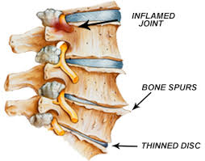

A spine model showing disc degeneration in the lower two discs with loss of disc height and bone spurs.
Degenerative disc disease is usually the result of aging and the majority of individuals older than 50 will have disc degeneration. However, younger people can have degenerative disc as well, especially if they sustain injuries to the spine.
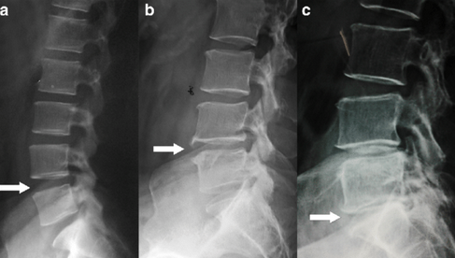

Assessment of the x-ray features of lumbar disc degeneration-lateral x-ray of lumbar spine. Arrows-a – no disc space narrowing/anterior osteophyte (grade 0 lumbar disc degeneration), b – mild disc space narrowing and small anterior osteophyte, (grade 1 lumbar disc degeneration) c – moderate disc space narrowing and small anterior osteophyte (grade 2 lumbar disc degeneration)

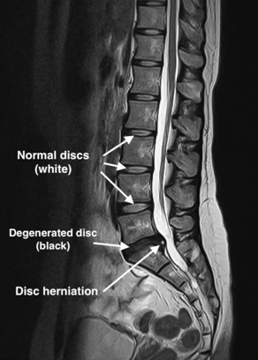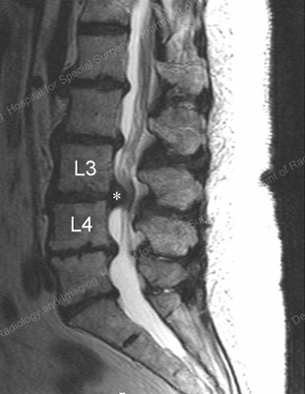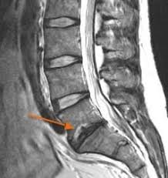

MRI is useful for assessment of disc degeneration and spinal stenosis, pressure on the spinal nerve that causes leg pain. Degenerative disc is usually dark due to loss of water. A degenerative disc loses disc height.
Non-surgical management of degenerative disc disease:
- Bed rest for a few days
- Avoid heavy lifting
- Physical therapy and home exercise program including stretching, may improve the flexibility of the trunk muscles. Other non-aerobic exercises may help to improve muscular endurance, coordination, strength, and facilitate weight loss. Exercise also helps to combat anxiety and depression which help coping with pain
- A spine brace for a short period to reduce the loads (weight) on the lumbar spine
- Over the counter muscle relaxant and anti-inflammatory medications
- Prescription medications
- Spine injections
Surgical management of degenerative disc disease:
Although most degenerative disc disease patients respond well to non-surgical treatments, some patients do need surgery. Surgery should be considered only after you've tried several months of non-surgical treatment. Surgical management of degenerative disc usually includes decompression of the spine to take the pressure of the nerve and fusion of the spine.

