Hossein Elgafy, MD, FRCSEd, FRCSC, MBA Professor of Orthopedics Chief of Spine

The word spondylolisthesis derives from two parts: spondylo which means spine, and listhesis, which means slippage. So, a spondylolisthesis is a forward slip of one vertebra relative to another. Spondylolisthesis usually occurs towards the base of the spine in the lumbar area. Spondylolisthesis can be described according to its degree of severity. One commonly used description grades spondylolisthesis, with grade 1 being least advanced, and grade 5 being most advanced.
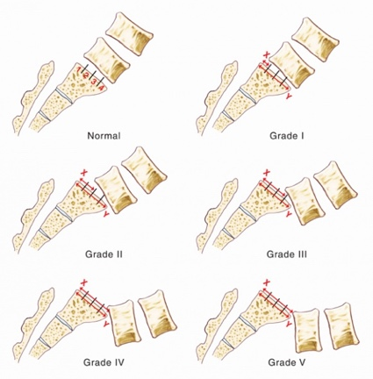

Approximately 5%-6% of males, and 2%-3% of females have spondylolisthesis. It becomes apparent more often in people who are involved with very physical activities such as weightlifting, gymnastics, or football. The increased physical activities of adolescence and adulthood, along with the wear-and-tear of daily life, result in spondylolisthesis being most common among adolescents and adults.

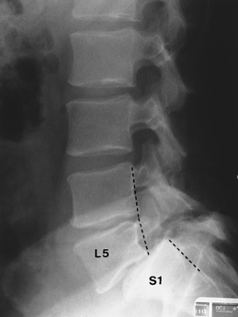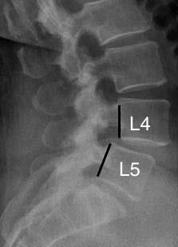
This x-ray shows spondylolisthesis in the lower back. Look at where the lines are pointing the vertebra above has slid out over the vertebra below it.
Types of Spondylolisthesis: Different types of spondylolisthesis may be caused in various ways:
- Developmental spondylolisthesis may exist at birth, or may develop during childhood, but generally is not noticed until later in childhood or even in adult life
- Acquired spondylolisthesis can be caused in one of two ways:
  - With all of the daily stresses that are put on a spine, such as carrying heavy items and physical sports, the spine may wear out. As the connections between the vertebrae weaken, this may lead to degenerative spondylolisthesis
  - A single or repeated force being applied to the spine can cause spondylolisthesis such as the impact of falling off a ladder and landing on feet, or the regular impact to the spine endured by playing football
Symptoms of Spondylolisthesis: Many people with a spondylolisthesis will have no symptoms and will only become aware of the problem when it is revealed on an x-ray for a different problem. However, there are several symptoms that often accompany spondylolisthesis:
- Pain in the low back, especially after exercise
- Pain and/or weakness in one or both thighs and legs
- Reduced ability to control bowel and bladder function
- Tight hamstring musculature
- In cases of advanced spondylolisthesis changes may occur in the way people stand and walk
Non-surgical management: Approximately 5% of the population has spondylolisthesis, most of whom will never need any treatment as their spondylolisthesis is stable and non-progressive. For adults, treatment is only recommended for those patients who have pain and disability. For children, treatment is necessary if they have pain, and when the forward vertebral slip is progressing. Observation is adequate for the adult who has no symptoms or the child who has a minimal spondylolisthesis and no symptoms.
Most patients with spondylolisthesis should avoid activities that might cause more stress to the spine, such as heavy lifting and sports activities like gymnastics, football, and diving. Patients must discuss their daily activities and hobbies with their physician to see if they are all right to continue.
- Physical therapy and home exercise program, physical therapist may use traction, electric stimulation, hot packs and cold packs to reduce pain, inflammation and muscle spasm
- Over the counter muscle relaxant and anti-inflammatory medications are used to reduce swelling and inflammation such as aspirin, ibuprofen (motrin, advil) and naproxen (aleve)
- Brace in certain situations is useful to provide additional support to the spine. This support may decrease muscle spasm and pain.
- Short course of oral corticosteroid medication for more severe pain because of their very powerful anti-inflammatory effect
- Spine injections: Epidural injections or nerve block may be recommended for severe pain. These are injections of corticosteroid into the epidural space (the area around the spinal nerves). The purpose of the injection is to reduce inflammation of the nerve
Surgical management: Surgery may be recommended if nonoperative measures have not improved the problem. Surgical management usually includes decompression of the spine to take the pressure of the nerve and fusion of the spine to prevent further slipping.

