Hossein Elgafy, MD, FRCSEd, FRCSC, MBA Professor of Orthopedics Chief of Spine

Compression, wedge, fracture is a common fracture of the spine. It implies that the vertebral body has a crush or wedging injury. When an external force is applied to the spine, such as from a fall or carrying of a sudden heavy weight, the forces may exceed the ability of the bone within the vertebral body to support the load. This may cause the front part of the vertebral body to crush forming a wedge shape. This is known as a compression fracture.

The compression fracture usually occurs in the lower and mid back causes minimal pain, minimal deformity and is often treated with time and activity modification. In some cases, compression fractures may cause more significant pain, and a hunched forward deformity (kyphosis). Neurologic injury is rare with compression fractures.

The risk for spinal compression fracture increases with age. Osteoporosis is the most common risk factor for compression fractures. Osteoporosis is a condition in which there is thinning of the bones, weakening them. This may be due to certain medications, age, inactivity, genetic factors, or a lack of calcium in the diet.

Compression Fracture Treatment: The majority of mild to moderate compression fractures are treated with immobilization in a brace or corset for a period of six to twelve weeks. The duration of treatment is based on symptoms and x-rays. As pain subsides and x-rays shows no change in the position of the spine and healing of the fracture, the brace may be discontinued.
The purpose of the brace is to help reducing the pain by immobilizing the fracture. It also helps to reduce the eventual loss in height and in angulation from the fracture. Compression fractures treated in a brace tend to have less deformity than those treated without a brace. Occasionally, bracing beyond twelve weeks is necessary in those patients with severe osteoporosis.

Kyphoplasty and Vertebroplasty: Minimally invasive spine surgery (MISS) for vertebral compression fracture is a procedure of injecting bone cement into the broken vertebral body to stabilize the fracture and reduce the pain. This procedure can be done with a balloon (kyphoplasty) or without a balloon (vertebroplasty). Both procedures are performed under local or general anesthesia. Both kyphoplasty and vertebroplasty are used in improving the back pain from the fracture.

Balloon Kyphoplasty: After a small pathway is created into the fractured bone, a small orthopedic balloon is guided into the vertebra. The balloon is gently inflated to create a cavity within the vertebral body. The cavity is filled with medical cement that sets to stabilize the fracture and reduce pain.

Vertebroplasty: A catheter is advanced into the compressed vertebra. Through the catheter, bone cement is injected into the fractured vertebra. The bone cement hardens to stabilize the vertebral body.
Recovery and Future Fracture Prevention: Most patients can expect to make a full recovery from their compression fracture. Most patients can return to a normal exercise program six months after a vertebral compression fracture. Regular exercise, including anti-gravity movements is recommended to help increase bone density and prevent future compression fractures. A healthy diet, bone building supplements and prescription medications can help increase bone mineral density needed for strong bones.

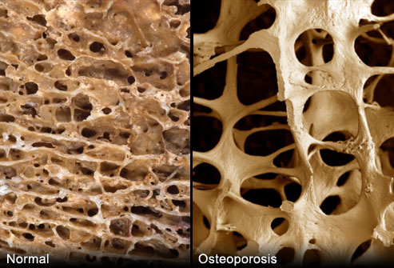
Osteoporosis is a bone disease that occurs when the body loses too much bone, makes too little bone, or both. As a result, bones become weak and may break from a minor trauma such as fall or minor activities such as bending over to pick something up or sneezing.
Osteoporosis means “porous bone.” Viewed under a microscope, healthy bone looks like a honeycomb. When osteoporosis occurs, the holes and spaces in the honeycomb are much larger than in healthy bones. Osteoporotic bones have lost density. As bones become less dense, they weaken and are more likely to break. The most common bones that break due to osteoporosis are spine vertebra, the wrist and the hip. When someone suffers a compression fracture, especially women older than 50, most likely the patient has osteoporosis. To avoid another fracture, it is recommended to get a bone density scan (DEXA san) to assess the osteoporosis and start treatment.

